|  |  |
| --- | --- |
|  |  |
| Insight Document |  |
|  |  |
|  | Date- 23-01-2024STUDENT’S NAME- Saurabh Patil |

# Document of Understanding

#### **How many olympics games have been held?**



#### **List down all Olympics games held so far.**

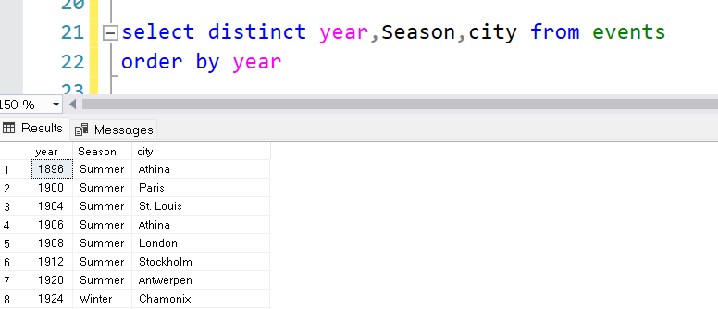

#### **Mention the total no of nations who participated in each olympics game?**

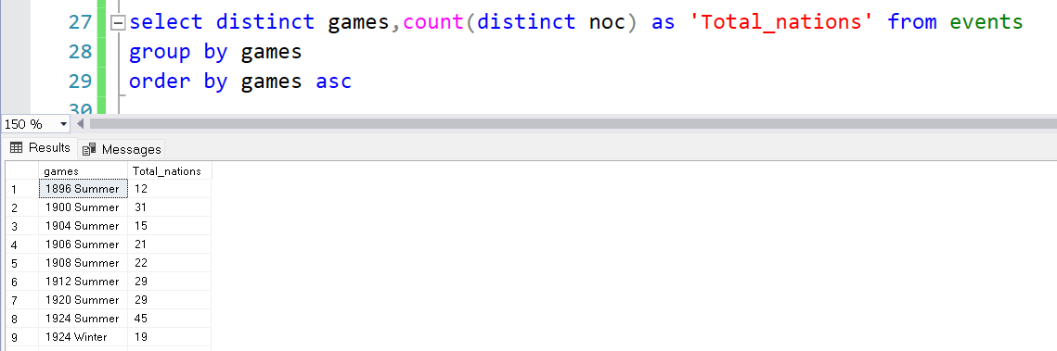

#### **Which year saw the highest and lowest no of countries participating in olympics?**

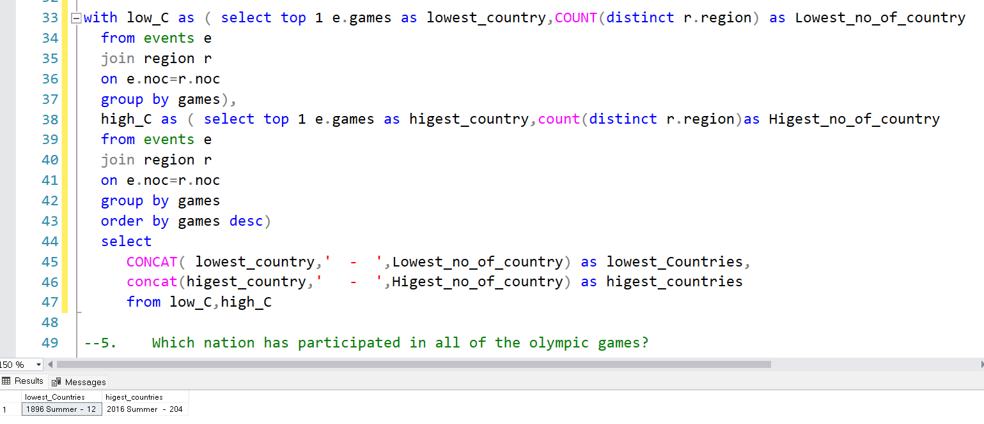

#### **Which nation has participated in all of the olympic games?**

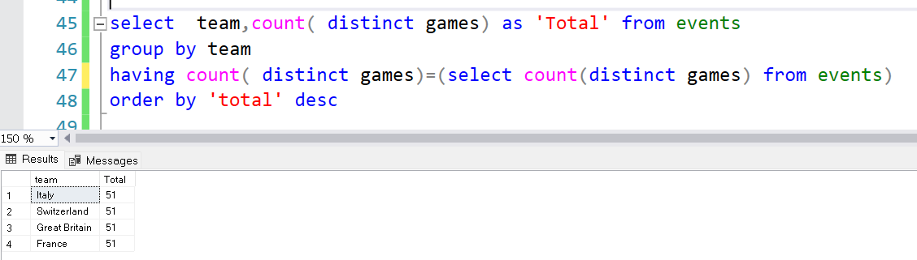

#### **Identify the sport which was played in all summer olympics.**

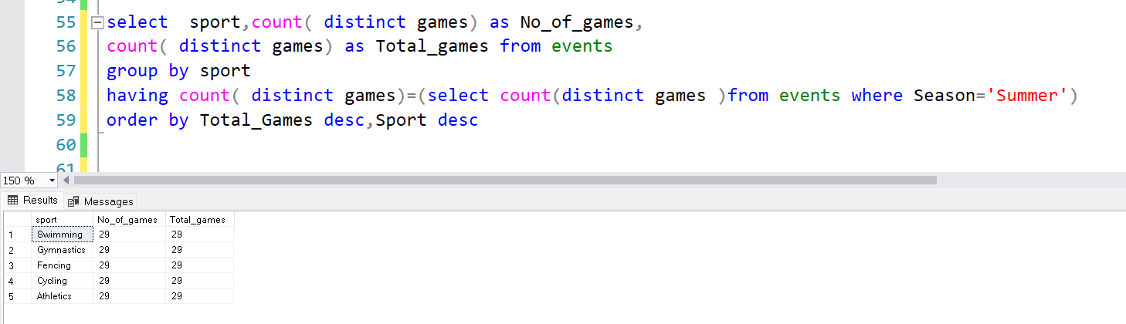

#### **Which Sports were just played only once in the olympics?**

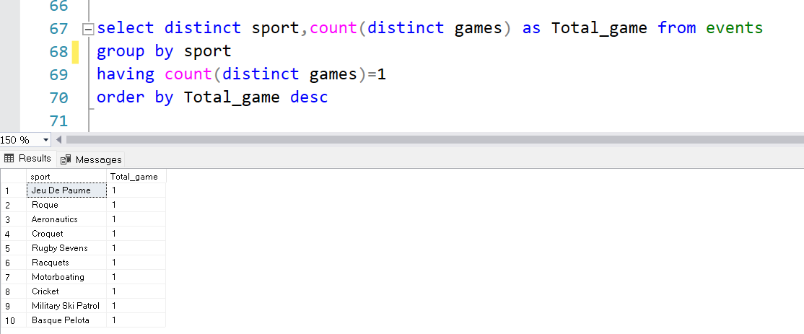

#### **Fetch the total no of sports played in each olympic games.**

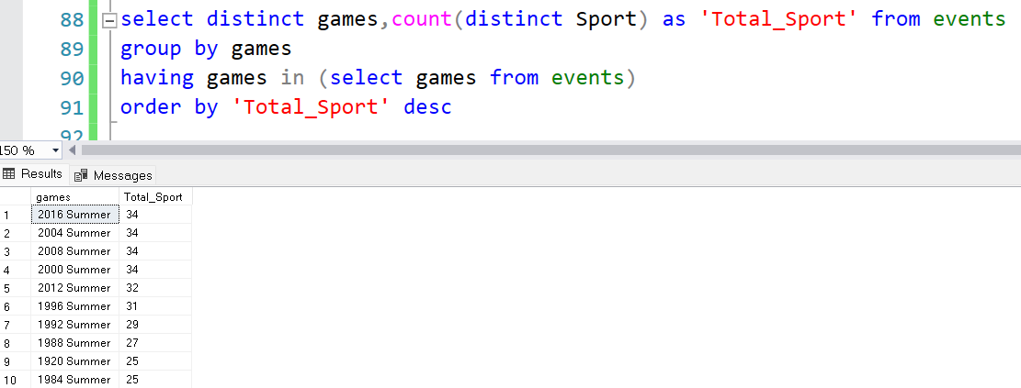

#### **Fetch details of the oldest athletes to win a gold medal.**

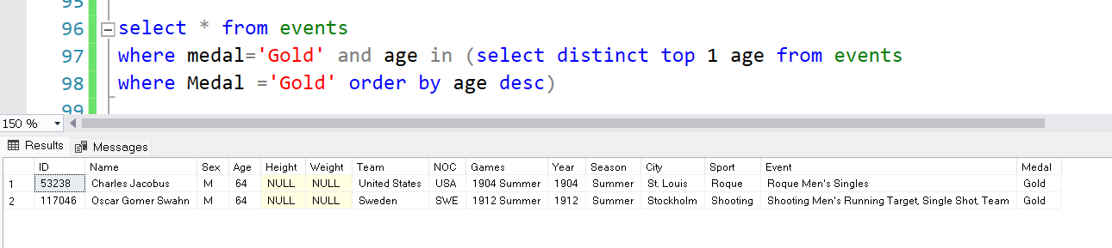

#### **Find the Ratio of male and female athletes participated in all olympic games.**

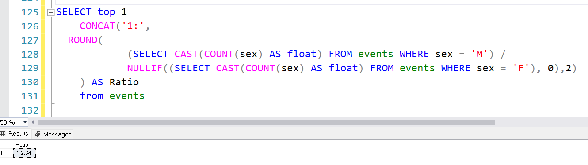

#### **Fetch the top 5 athletes who have won the most gold medals.**

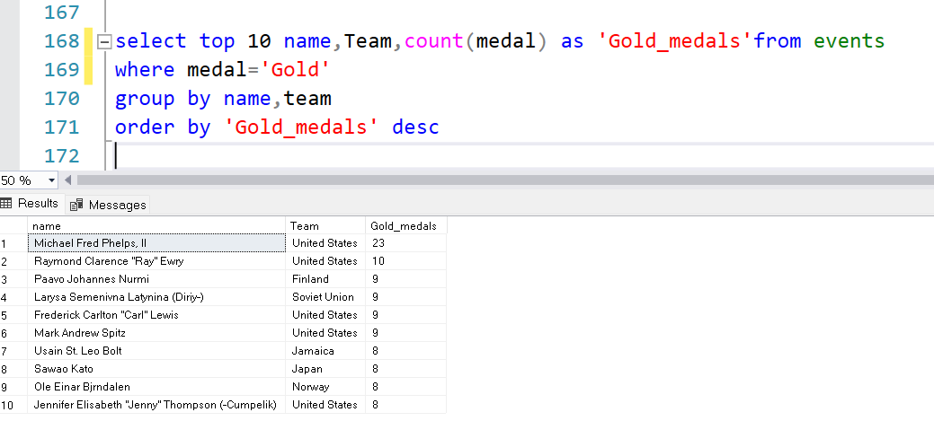

#### **Fetch the top 5 athletes who have won the most medals (gold/silver/bronze).**

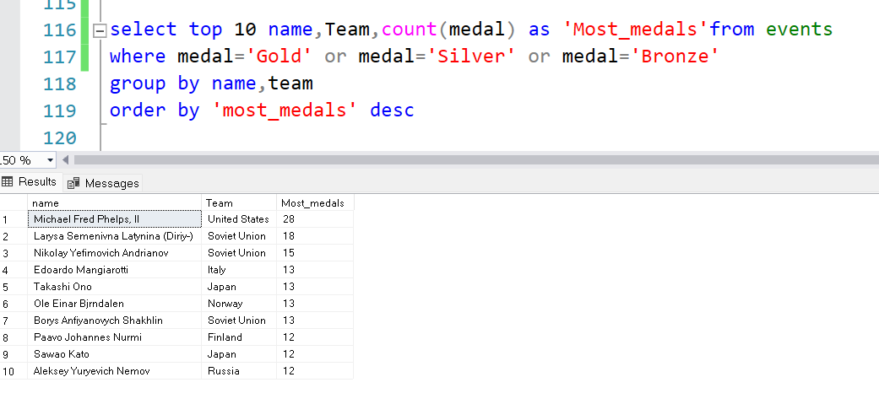

#### **Fetch the top 5 most successful countries in olympics. Success is defined by no of medals won.**

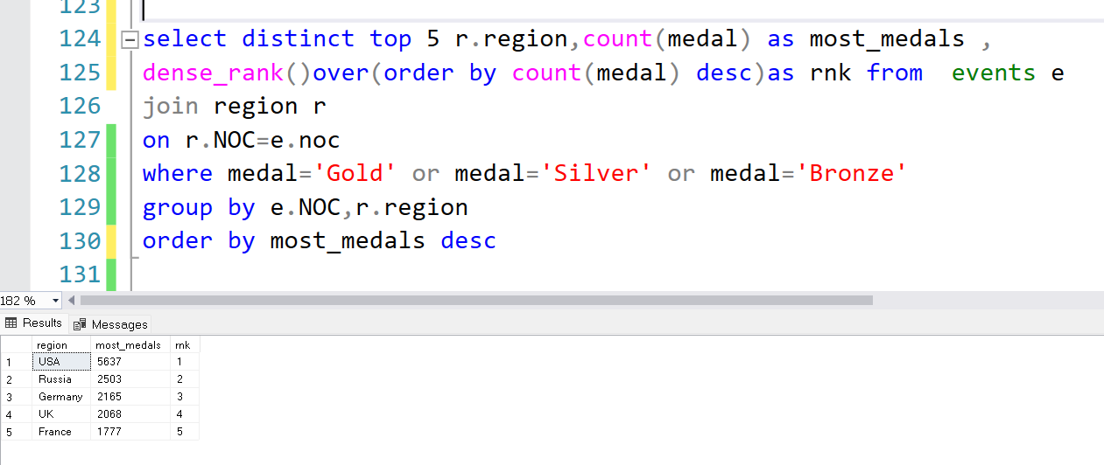

#### **List down total gold, silver and broze medals won by each country.**

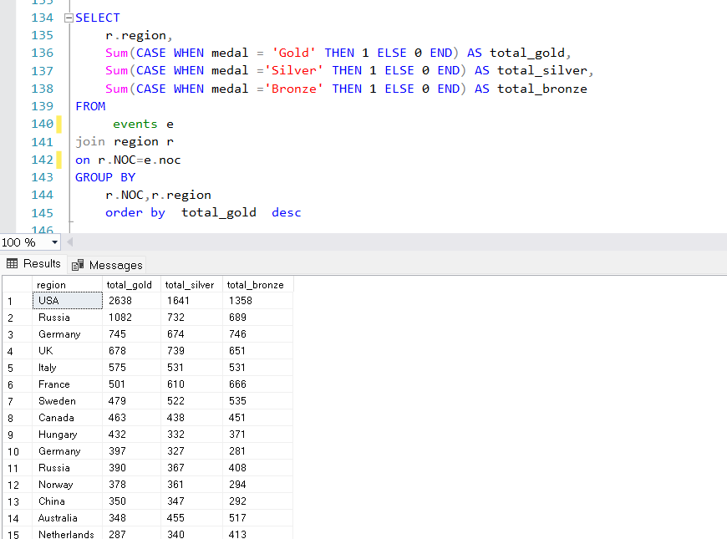

#### **List down total gold, silver and broze medals won by each country corresponding to each olympic games.**

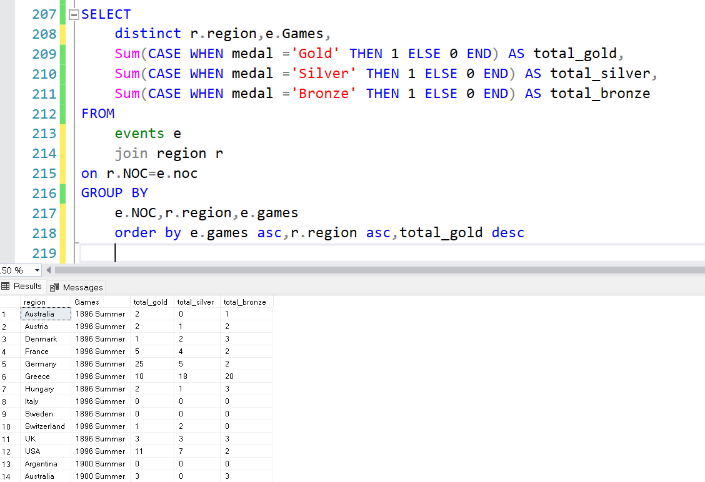

#### **Identify which country won the most gold, most silver and most bronze medals in each olympic games.**

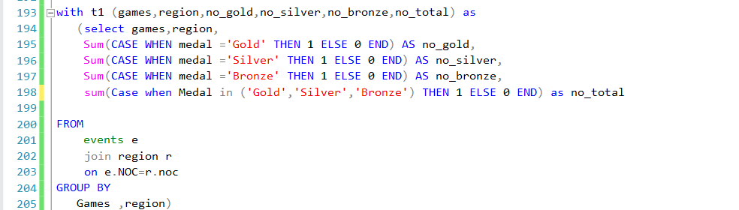

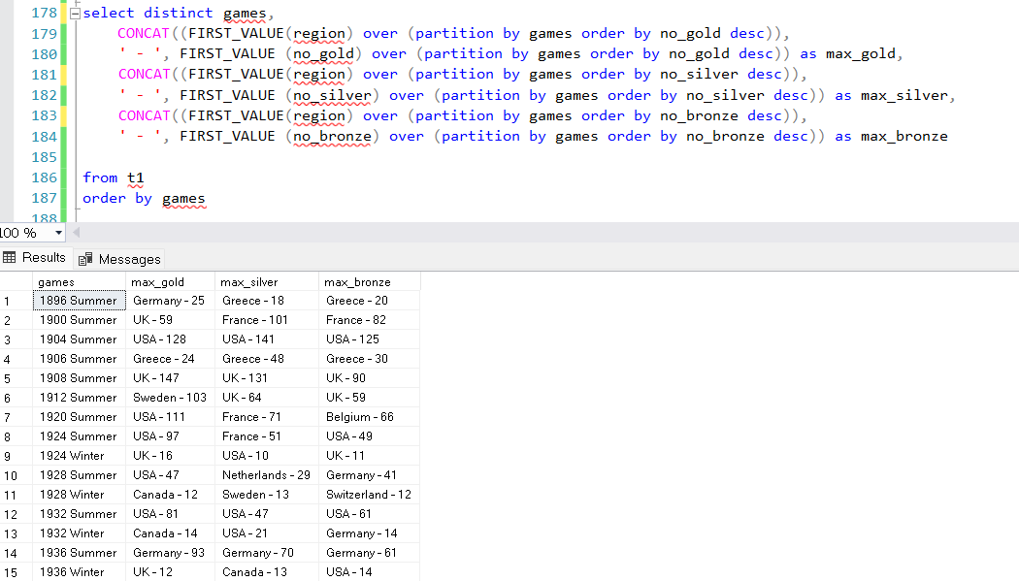

#### **Identify which country won the most gold, most silver, most bronze medals and the most medals in each olympic games.**

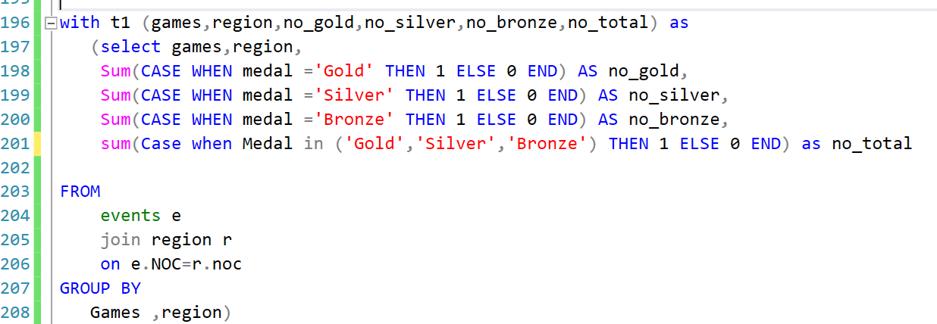

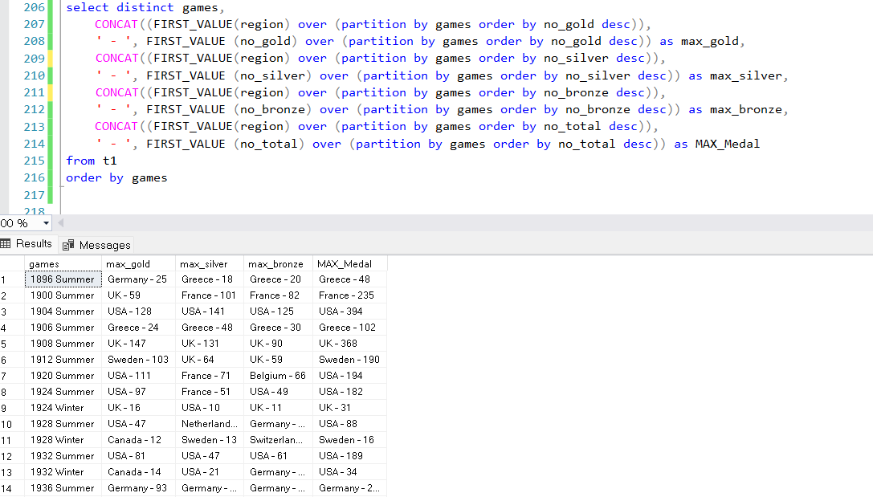

#### **Which countries have never won gold medal but have won silver/bronze medals?**

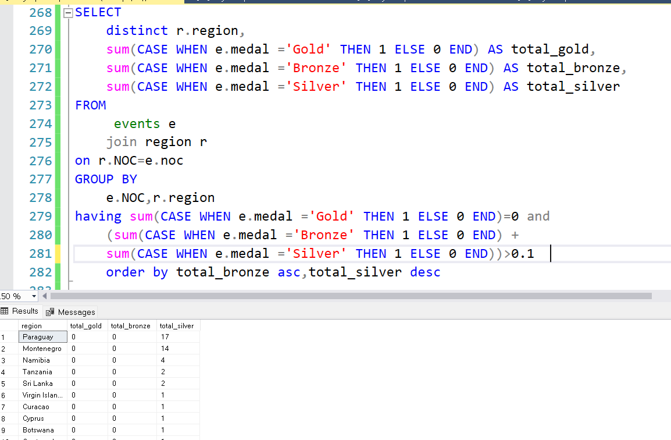

#### **In which Sport/event, India has won highest medals.**

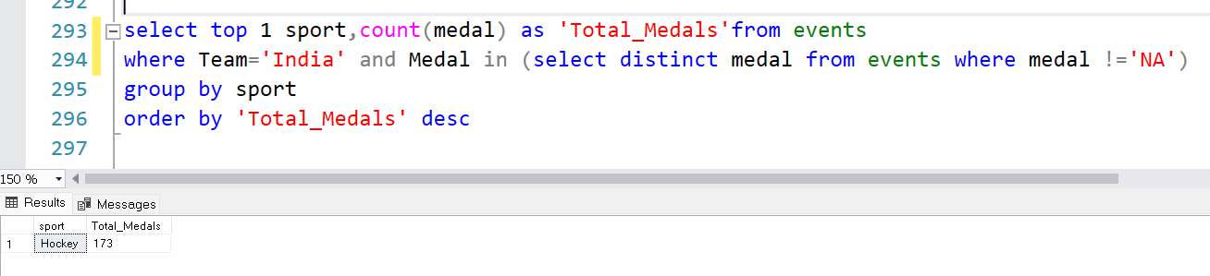

#### **Break down all olympic games where india won medal for Hockey and how many medals in each olympic games.**

